Date: January 2021
Department : GIO - Global Infrastructure and Operations

This document is • INTERNAL

This document and the information contained herein is L'Air Liquide S.A. or one of its affiliates' property. The document is confidential business information and may furthermore contain confidential technical information. It is provided to certain employees of the Air Liquide group for their internal use exclusively in the course of their employment. Any reproduction or disclosure of all or part of this document to third parties is prohibited without the express written consent of an authorized representative within the Air Liquide group. If you have received this document by mistake, please immediately notify the sender and destroy the original message.

Applies to computers, tablets and smartphones
This document aims at providing an understanding of how to use Loop, the Air Liquide office management solution to reserve a desk or a meeting room.

Prerequisites:
- You have an Air Liquide email address (also works for subcontractors with -sc email addresses)
- Your device is connected to the internet (Air Liquide network or another internet network)

Table of Contents
First steps
Sign in (web version via Chrome browser)
Sign in (mobile version iOS/Android)
Sign out
Getting started
Book a desk
Release a desk
Book a meeting room
From Maps section
From Meeting rooms section
Release a meeting room
Declare a incident
Locate a desk or a meeting room
Additional features
Visitors management
Join us
Transportation
News
Useful information
Security
On-site employees

First steps

Sign in (web version via Chrome browser)
From your computer connected to the Air Liquide or internet network, authentication is automatic: Just click on the blue link as shown below.

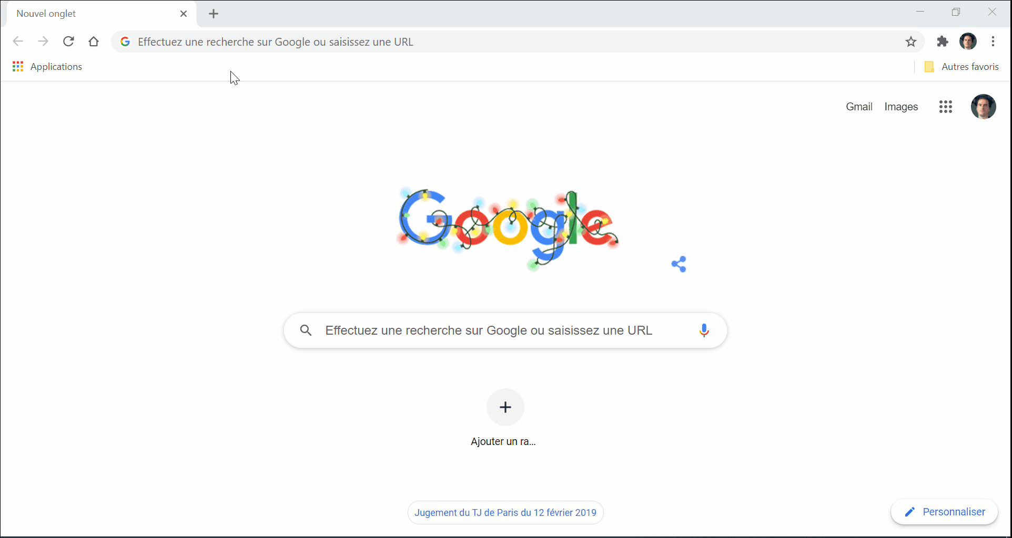

Sign in (mobile version iOS/Android)
Your phone must be enrolled in Intelligent Hub to be able to connect and access Loop app.

- Go to Intelligent Hub
- Find and install Loop
- Click on the blue button LOGIN WITH KITE
- Select your Air Liquide Kite account
- Click on Allow to accept the terms and conditions of the application

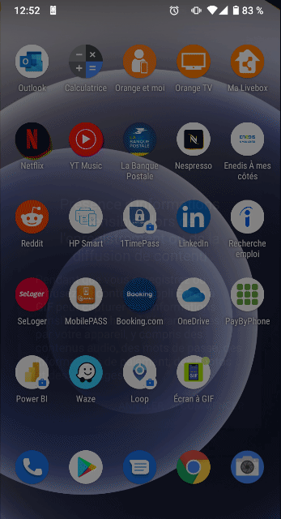

Sign out

To sign out, click on the top right corner button, then Log out:

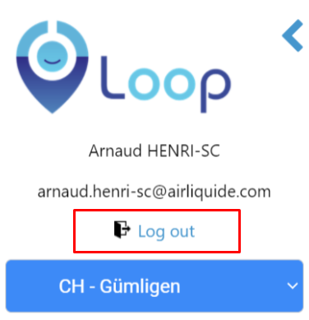

Getting started

Loop identifies 2 types of desk:

- Assigned desks: These desks are assigned to a specific person whose name is indicated on the desk. These desks are not bookable. However, a third party can declare their position there (for example a day when the assigned person is off)
- Reservable desks: Concerns flex-office sites. Reservable desks are marked in white on the card and contain the desk identifier (ex: 2_D_03). Once reserved, these desks turn red and indicate the name of the person who booked

Book a desk

You can temporarily reserve a desk in flex office site where desks are not assigned to dedicated users.
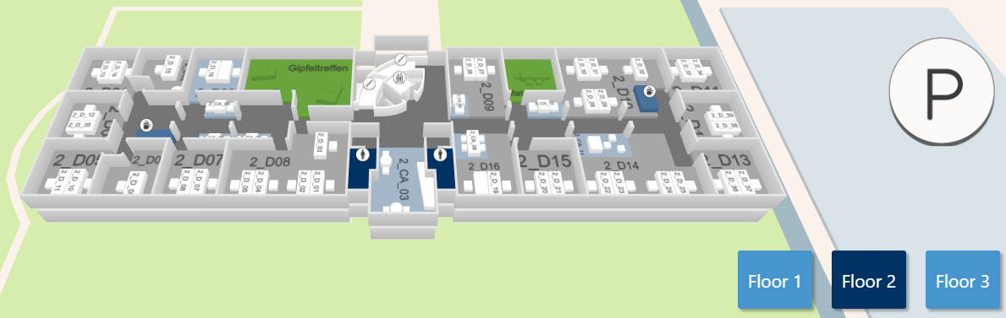 | Please note reservable desks are marked as white in the map and contain the desk identifier (ex: 2_D_03). Once reserved, these desks turn red and indicate the name of the person who booked.  Booked desks are marked as red and means the desk is not available for reservation.
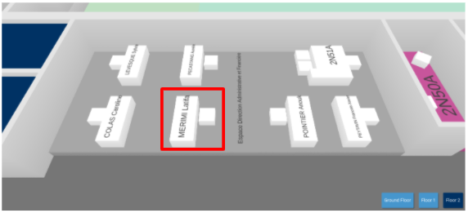
Assigned desks
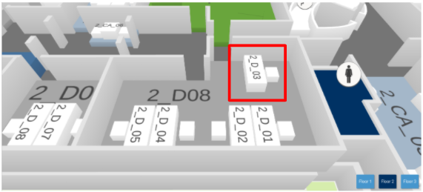
Reservable desks
To book a desk, click on Maps button from the main screen, locate the desk among the different floors then select the desk you want to book and click on Save my location button:

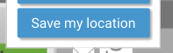

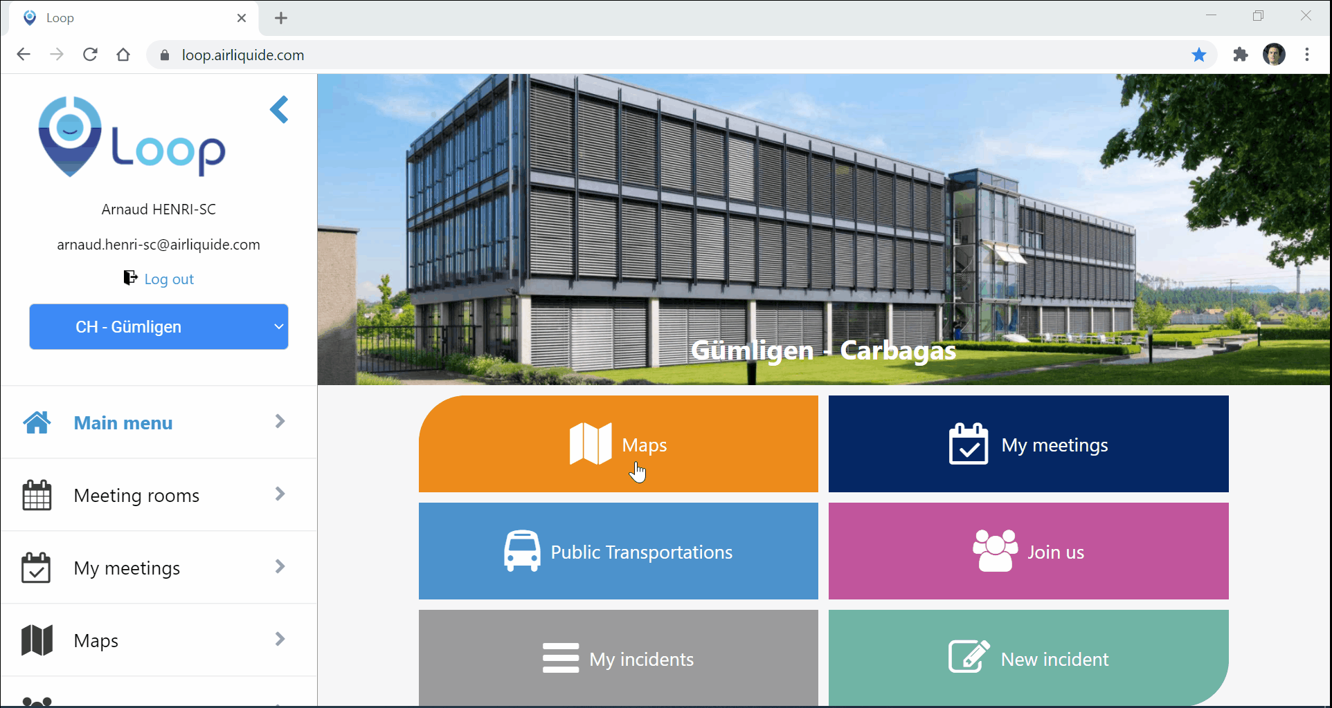

Once booked, the desk turns red:
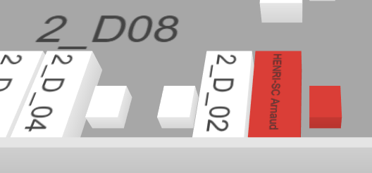

When the flex office is in place on your site, booking your desk lets your colleagues know which desks are available or not, as well as the location of your own desk.

Please note that for your site the bookable desks will be automatically vacated at a specific time every day.

Release a desk

You can release your desk when you leave. To do so, go on Maps section in the main screen, locate and select the desk then click on Delete my location:

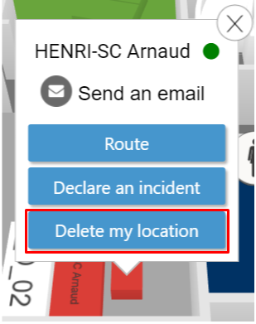 | Please note reservable desks are automatically released at specific time (at the end of the working hours defined by each facility managers of the site)  When you leave your desk, releasing it to Loop lets your colleagues know that the desk is available again.

Book a meeting room

From Maps section

You can book a meeting room from the Maps section on the main screen:

- Select the meeting room
- Click on Book button
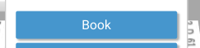
- Enter a name of the meeting
- Adjust the schedule date and time
- Add collaborators
- Click on Reserve room

IMPORTANT : Do not click on Save my location to reserve a meeting room!
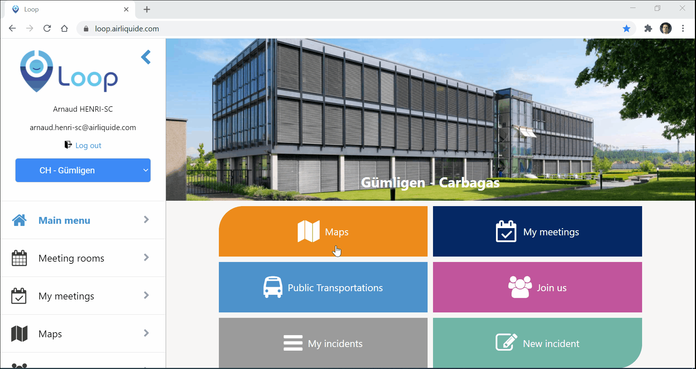

Please note that once booked, the concerned meeting room turns red:
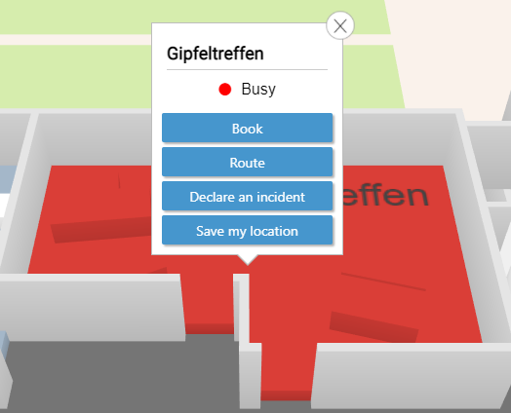

Reservations made in Loop are automatically synchronized in Google Calendar.

From Meeting rooms section

You can directly book a meeting room from the Meeting rooms section located on the left panel:

- Place on the line of the desired room
- Click on the desired time slot (1 hour by default) or drag to adjust the desired time slot.
- Enter a name of the meeting
- Adjust the schedule date and time
- Add collaborators
- Click on Reserve room

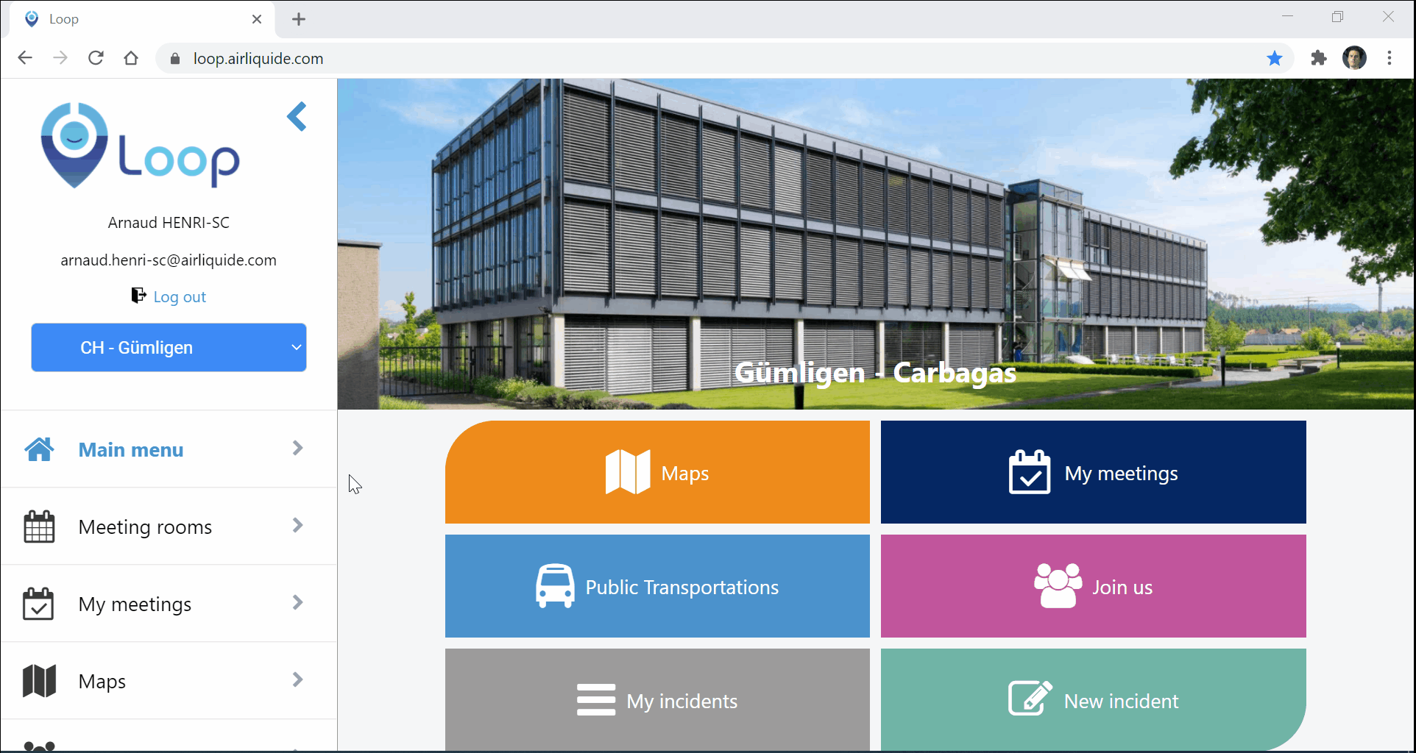

Once booked, the concerned meeting room turns red:

Reservations made in Loop are automatically synchronized in Google Calendar.

You can also use the filter at the top left according to the capacity, floor of the room or filter by period.

Release a meeting room

Once finished, select the concerned meeting room from the My meetings section on the left panel then click your meeting to release it:

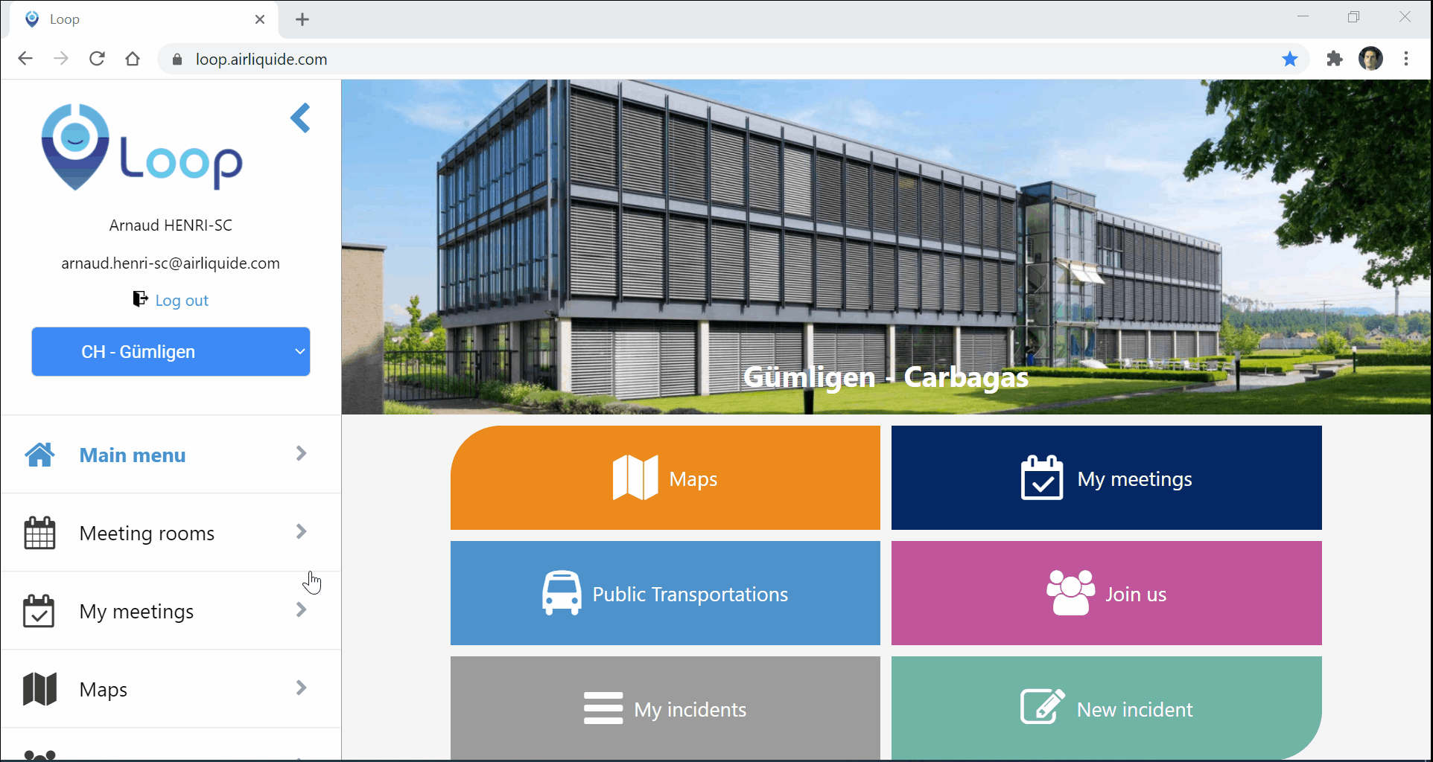
The meeting room automatically will turn green:

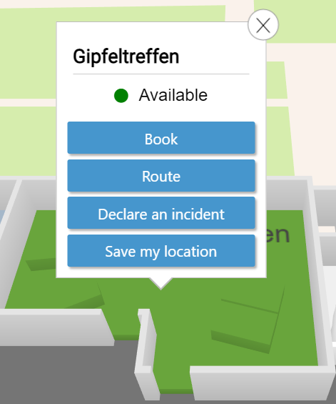

When you leave the meeting room early, remember to release it on Loop. This will let your colleagues know that the room is available again.

Declare a incident

You can report any office incident which can occur on site and which most generally involve Facility services. For instance:
- Broken chair
- Broken screen
- Missing cable

It is possible to report any incident that may occur at a desk, in a meeting room but also in common areas (break room, toilets, etc.)

With the mobile version, it is possible to take a photo / video directly with your phone when creating the incident

From the the left panel or the main screen, click on New incident or by selecting a desk directly from the Maps, then fulfill as follow:
- Enter a phone number
- Enter a name
- Enter a short description
- Put a photo (if available)
- Specify a location where the desk is located
- Submit the incident

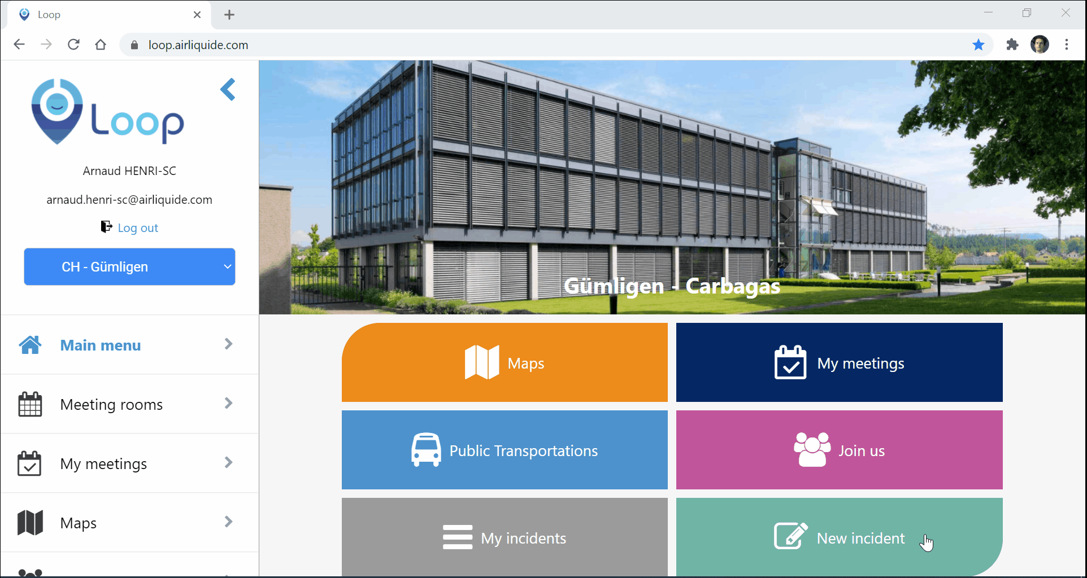

You will receive a notification by email to inform you that your incident is going to be managed by the facilities.
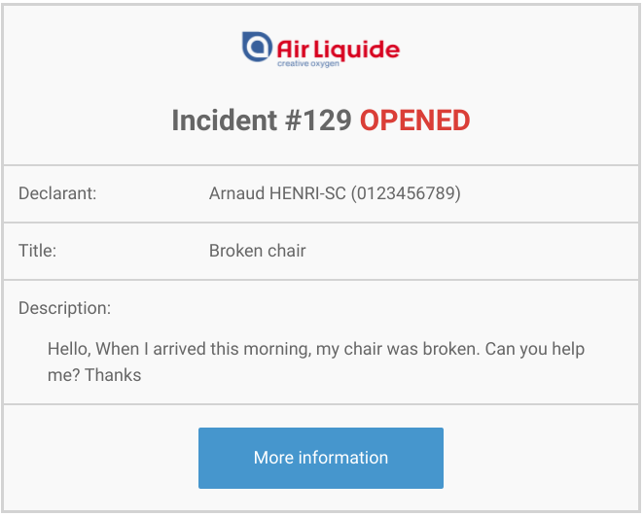

You will receive a second notification by email that your incident has been resolved with justifications.

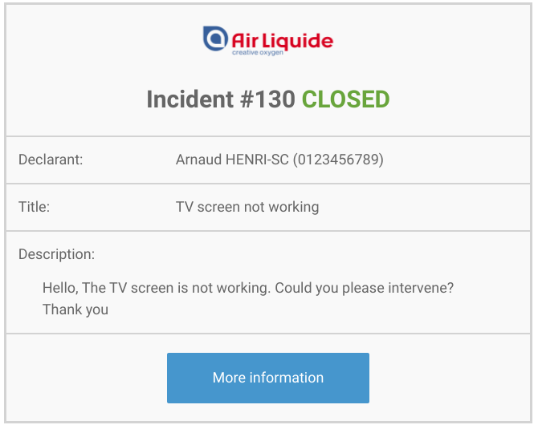

Locate a desk or a meeting room

You can use the route feature when clicking on a desk or a meeting room to locate your destination easily. A step-by-step will appear to guide you throughout the floor.
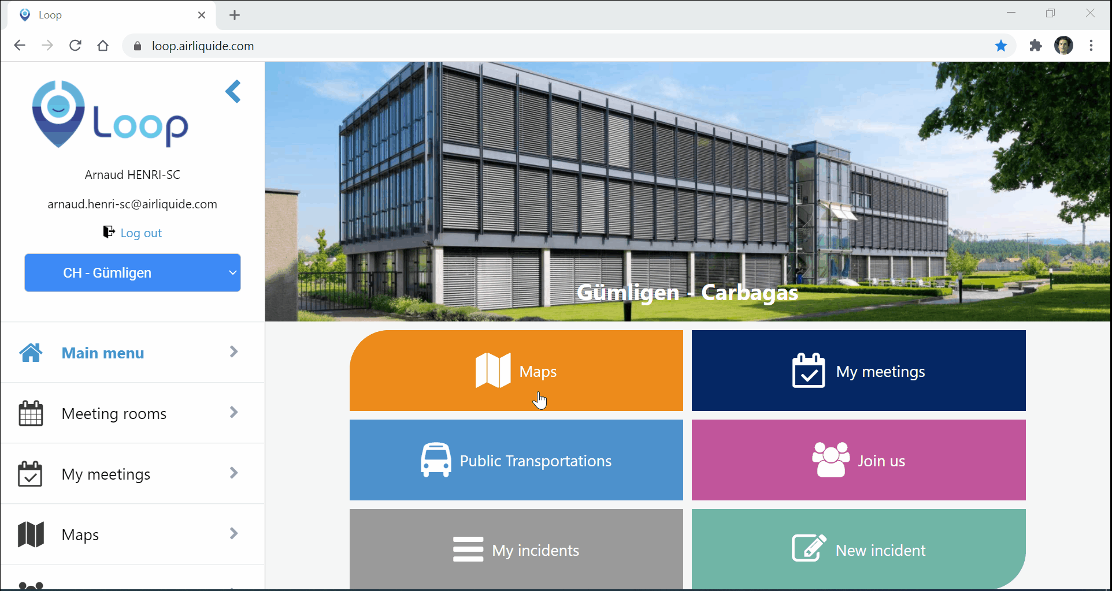

Additional features

Visitors management
Visitor management section refers to tracking the usage of an Air Liquide site for security reasons. By gathering increasing amounts of information, a Visitor Management System can record the usage of the facilities by specific visitors and provide documentation of visitor’s whereabouts.
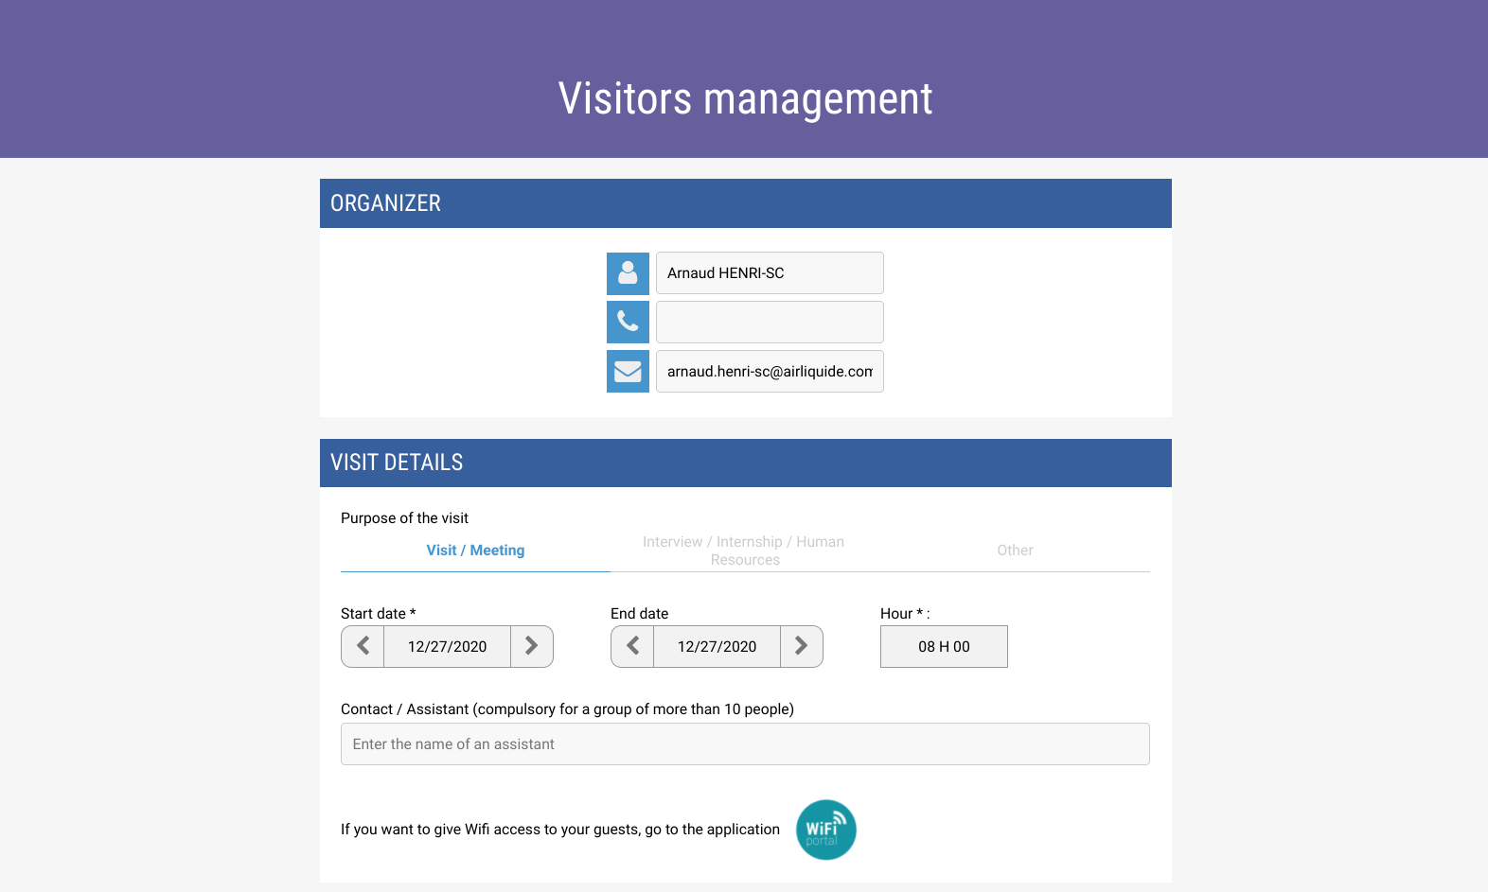

You have to specify information before the guest coming:
- Your identity and phone number
- Purpose of the visit
- Date and time of the visit
- A contact (if visit includes more than 10 peoples)
- Name, company and email of the guest
- Foreign nationality (for regulations reasons)
- Access to restricted areas (if needed)
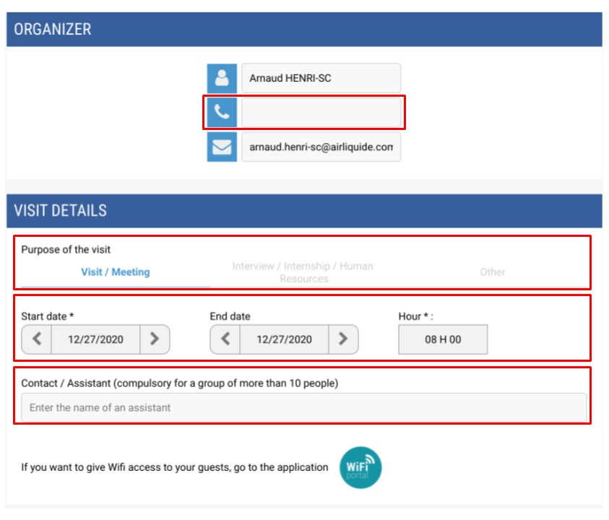 | 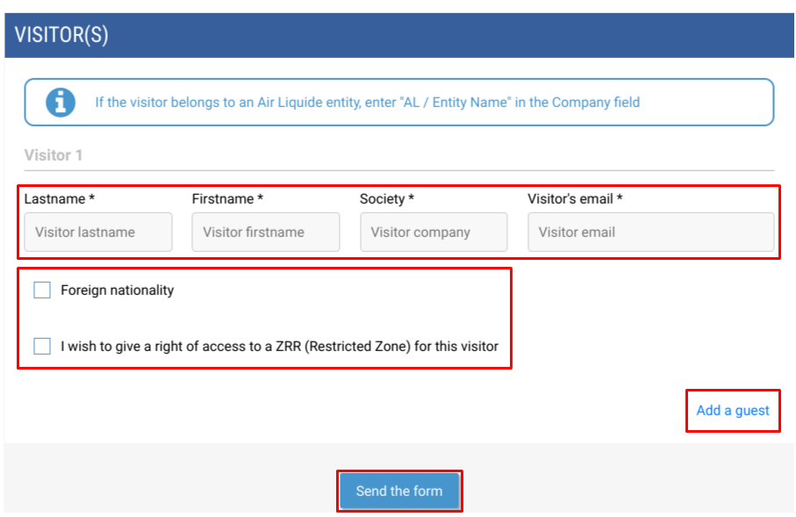

Join us
This section is useful to contribute or be helpful to others collaborators on the site. For instance, inform that you can take your colleagues home or you want to organize a workshop and define a schedule before creating the event in the calendar.

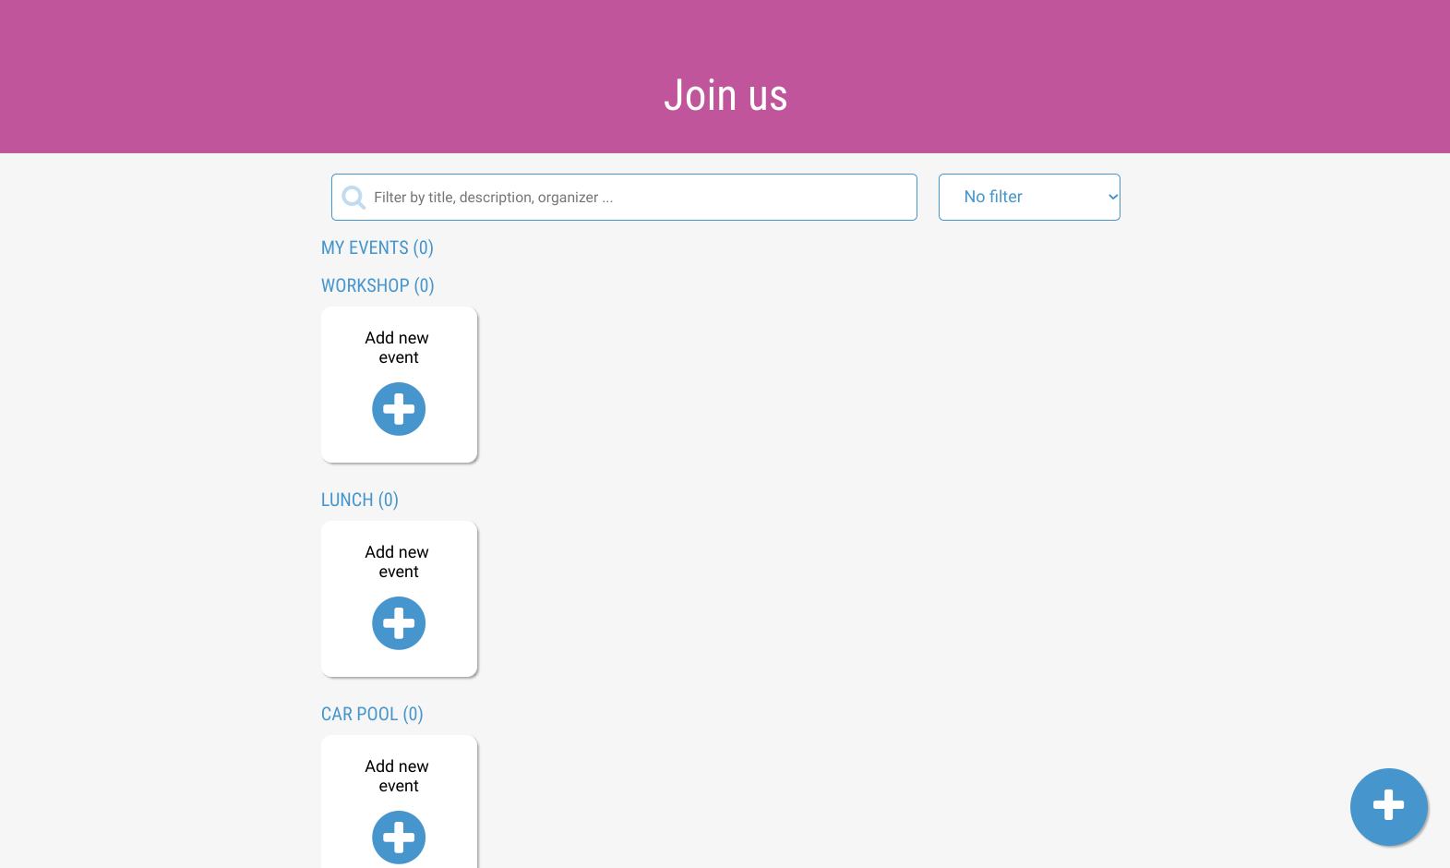

Transportation
Transportation section allows collaborators on site to be instantly informed on the traffic status or have the schedules for train and bus times.

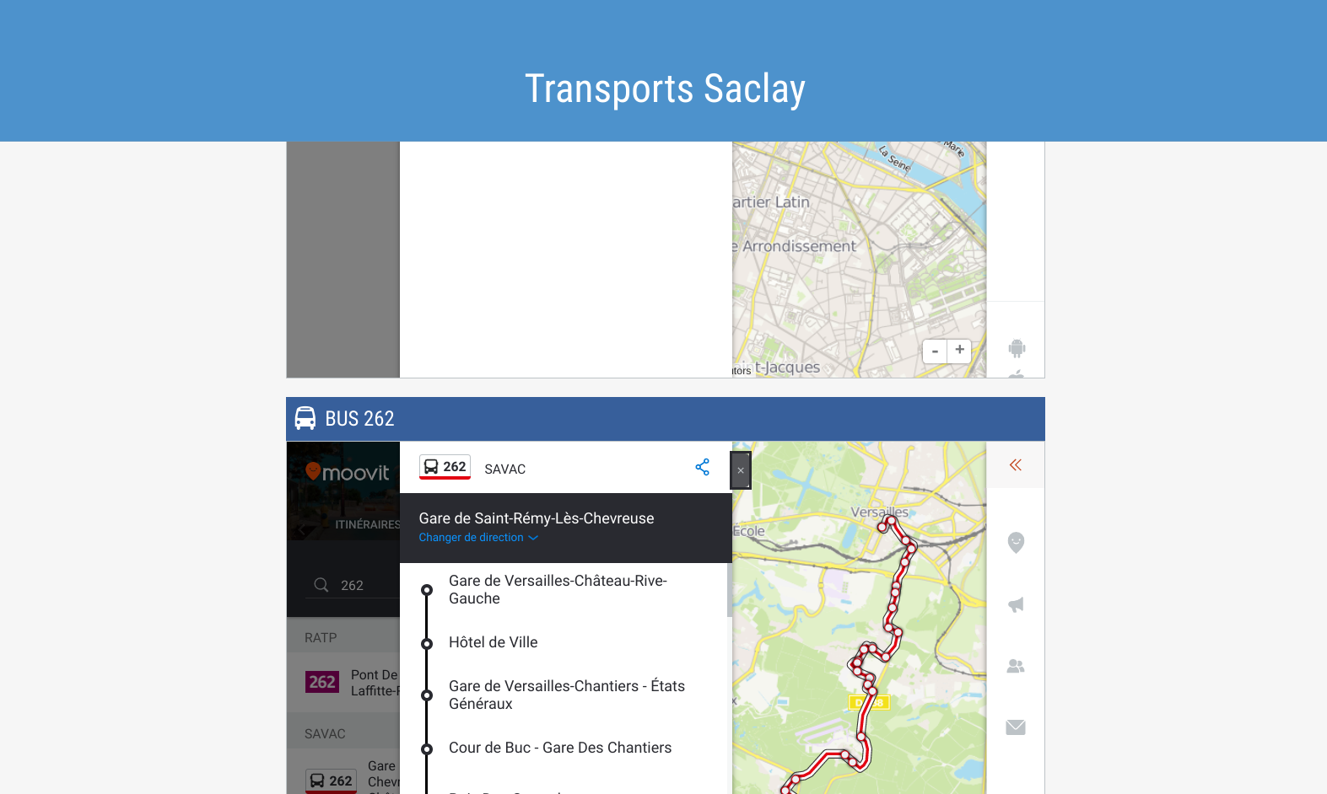

News
News allows facility managers to display some information content from community intranets (Lumsites) to be consulted over Loop. Can be consulted on mobile devices.

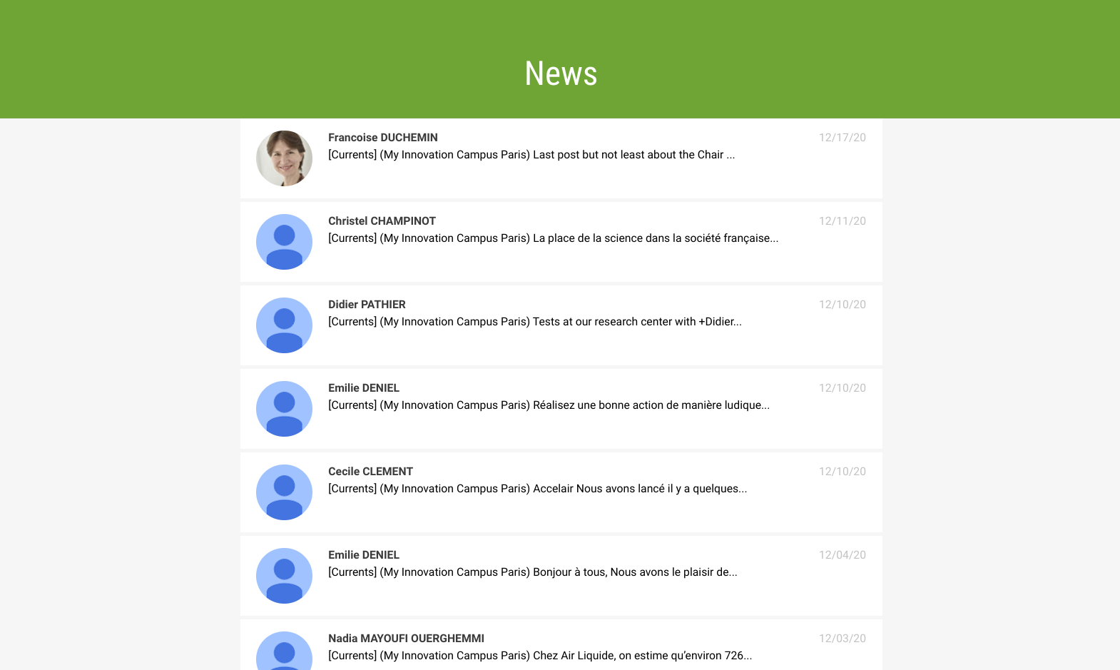

Useful information
Useful information gives information about the site like opening hours or how to register at the reception. You can also specify phone numbers for all services that can be provided by the facility.

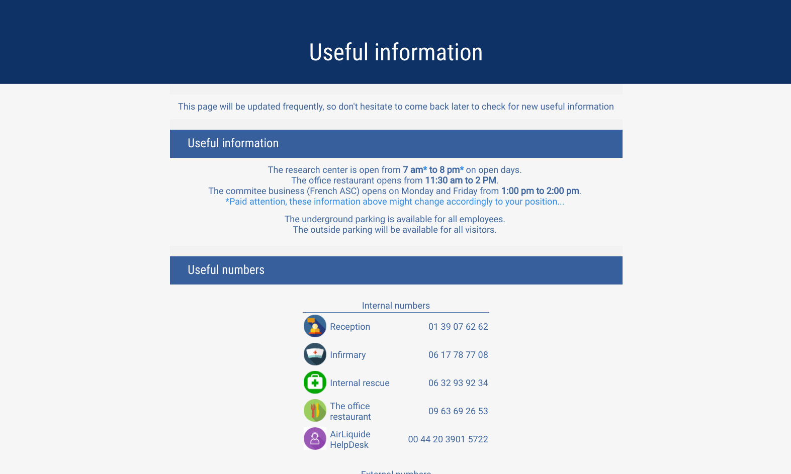

Security
The Security section allows you to provide direct phone numbers for emergency purposes or report injuries might occur on the site. A dedicated mobile version is available that allows collaborators to directly call the desired service instead of composing the phone number.

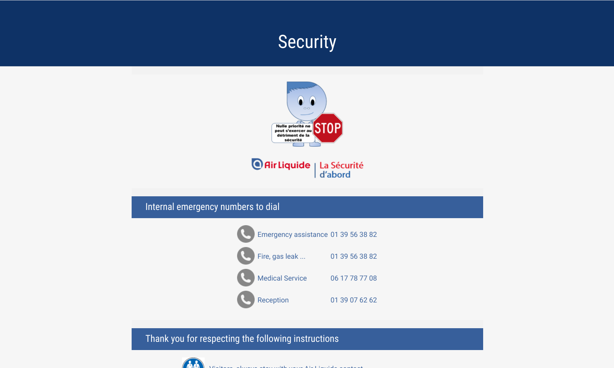

On-site employees
This section provides the list of collaborators which are on the site. It might be helpful for desk reservations where desks are assigned to specific persons.

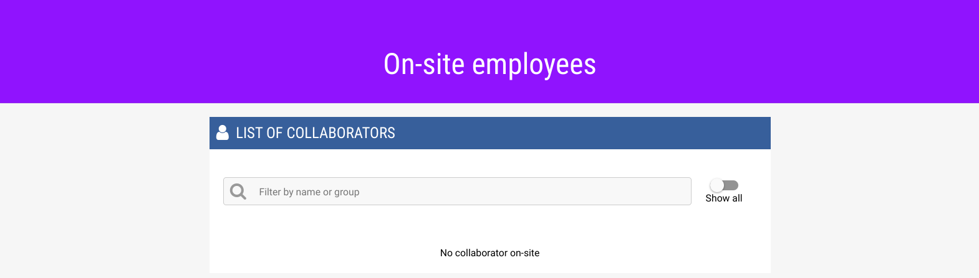

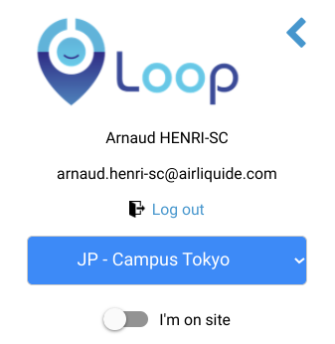 | 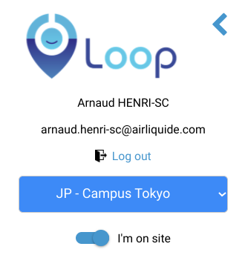
Inform you are not on site. It will be useful when you have a desk assigned to you but you are off. | When you enable the I'm on site module, you will be declared in the list of visitors in the on-site employees section.

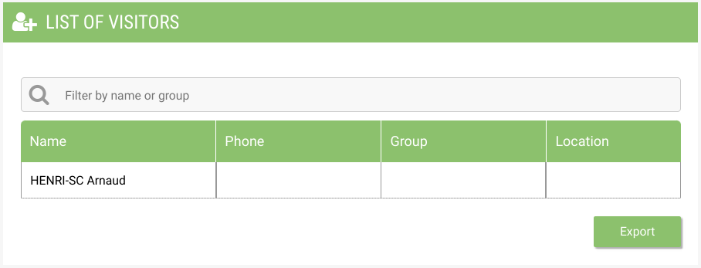
When I’m on site has been enabled, the name of the collaborator will be listed here.

Help section

Color legend

Available desk (without sensors)
Available desk (with sensors)
Available meeting room
Occupied Desk / meeting room

